**select** * **from** phone_book **where** surname **like** 'К%';

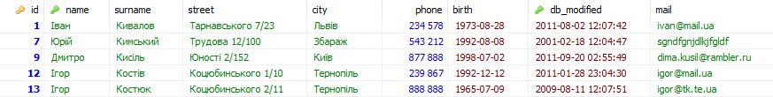

**select** * **from** phone_book **where** surname **like** 'К%' '%к';



**select** * **from** phone_book

**where** surname **like** 'К%' **and** birth > '1991-01-01' **and** (city **like** 'Збараж' **or** city **like** 'Тернопіль');



**select** id, name, surname, street **from** phone_book

**where** street **like** 'Незалежності 2%' ;



**select** * **from** phone_book

**where** birth > '1992-01-01' **and** city **like** 'Збараж';



**select** * **from** phone_book

**where** birth **between** '1970-01-01' **and** '1979-12-31';

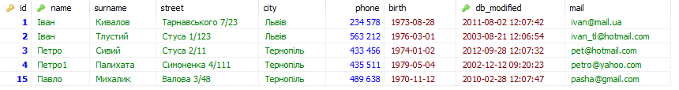

**select** * **from** phone_book

**where** id<='5';

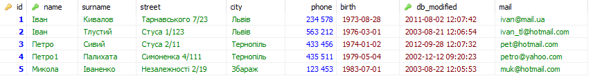

**select** * **from** phone_book

**where** city **like** 'Тернопіль'**and** birth **not** **between** '1970-01-01' **and** '1979-12-31' ;

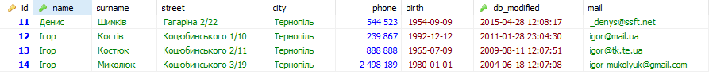

**select** * **from** phone_book

**where** id **in** (1,3,6,9,10,11,12);

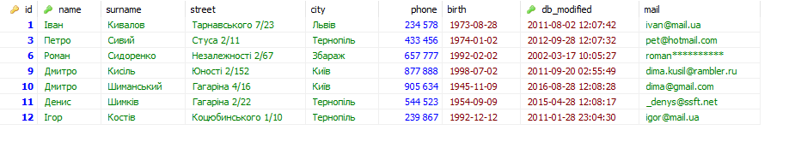

**select** * **from** phone_book

**where** id **in** (3,4,5,6,7,8);

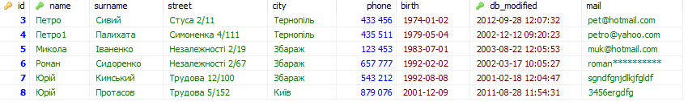

**select** * **from** phone_book

**where** id **between** 3 **and** 8;

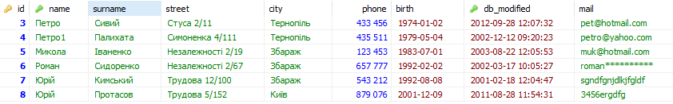

**select** * **from** phone_book

**where** id >='3' **and** id<='8';



**select** * **from** phone_book

**where** db_modified > '2011-01-01';

